Gel Documentation Form and Worksheet

HLA-C high resolution for frequent alleles

(101.707-12/12u) Lot No: 95V Expiry Date: 2017-February-01

Name:__________________
Sample ID:______________
DNA Conc.(ng/ul):_________

Test Date:_______________
Tested By:_______________

Review Date:_______________
Reviewed By:_______________ _

Gel Picture

PHOTO DOCUMENT

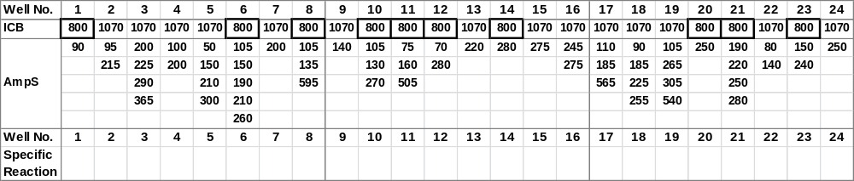
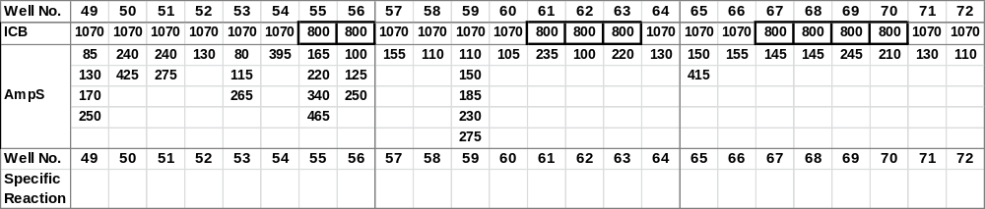

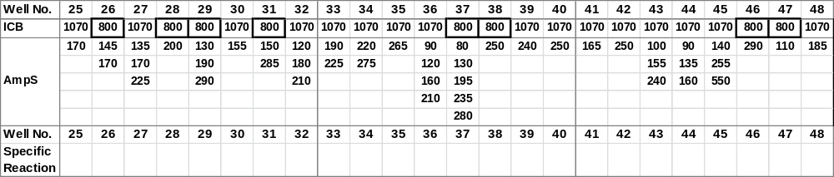
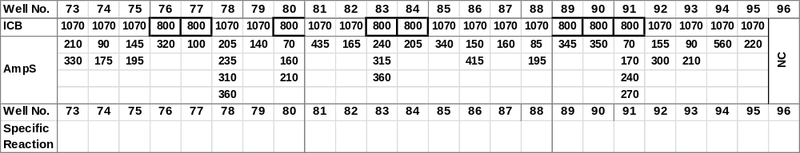
‘ICB’ Internal Control Band,
‘AmpS’ Amplicon Size

Interpretation:_______________
Failed lanes: _______________
Comments: ___________________

Notes:
Product sizes are approximate. For detailed information, see the lot-specific Specificity Table and Interpretation Table.
This table is intended as a guide. For interpretation always use the Interpretation Table and/or Specificity Table.

HLA-specific PCR products shorter than 125 base pairs have a lower intensity and are less sharp than longer PCR products.
Primer mixes 3, 5, 10, 21, 40, 44, 45, 57, 61, 62 and 86 may have tendencies of unspecific amplifications, most pronounced in primer mix 10.
Primer mixes 6, 20, 36 and 80 have a tendency to giving rise to primer oligomer formation.
Primer mixes 1, 10, 12, 17, 27, 53, 64, 72, 77, 82, 86, 87 and 93 may give rise to a lower yield of HLA-specific PCR product than the other HLA-C high resolution primer mixes.
Primer mixes 10, 44, 92 and 93 may give rise to a long unspecific amplification product. This band should be disregarded when interpreting the typing results.
Primer mix 64 may give rise to unspecific amplification in C*12 alleles.
Primer mix 96 contains a negative control, which will amplify more than 95% of HLA amplicons as well as the amplicons generated by control primer pairs. PCR product sizes range from 75 to 200 base pairs. The PCR product generated by the control primer pair is 430 base pairs.

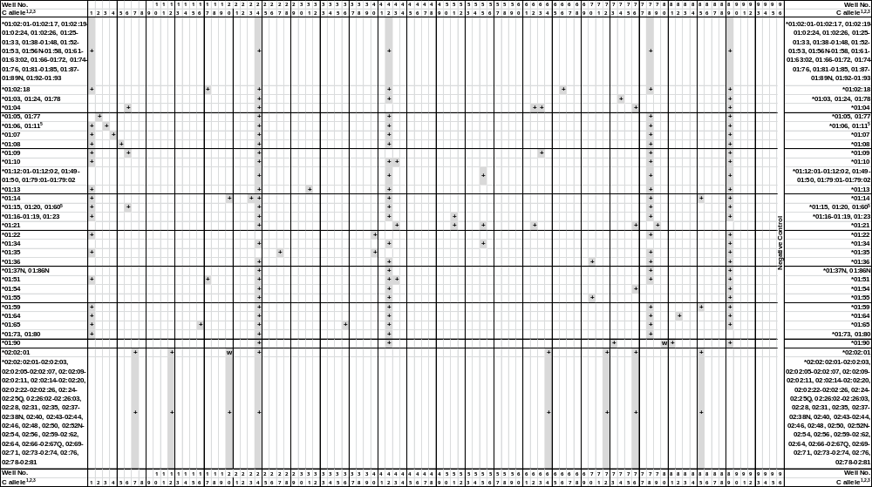
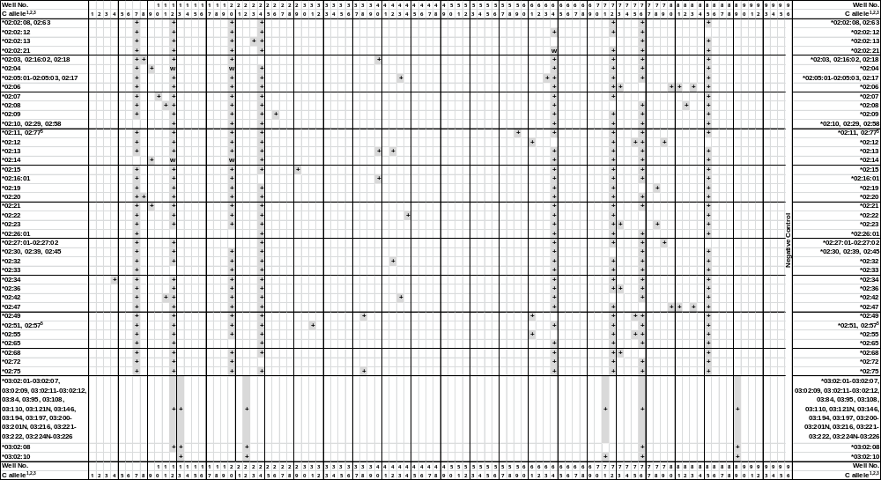
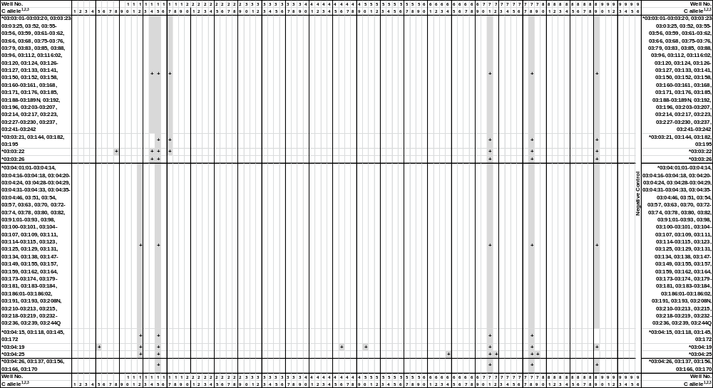
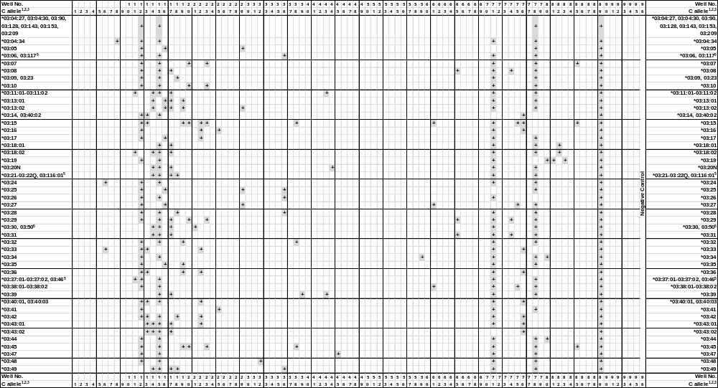
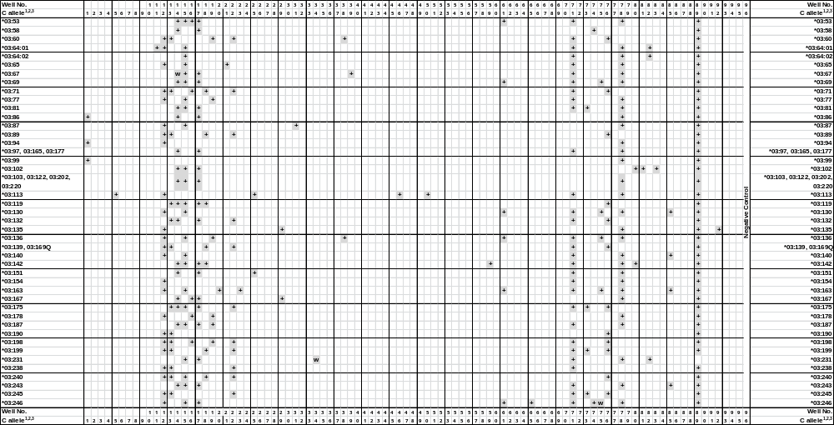
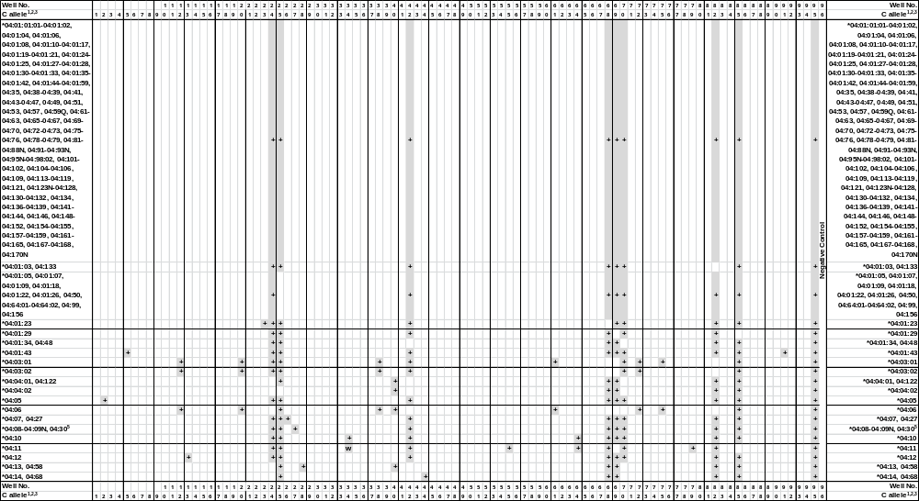
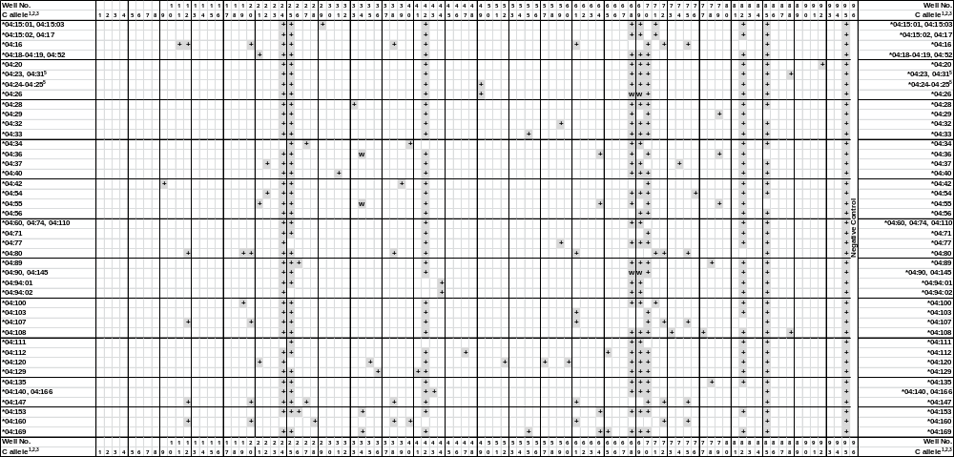
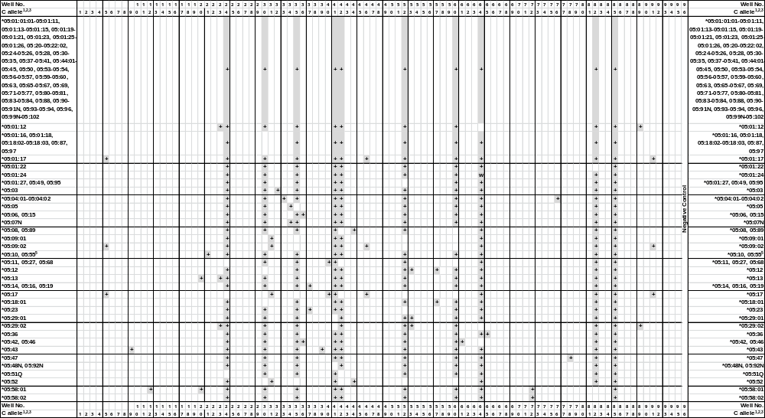
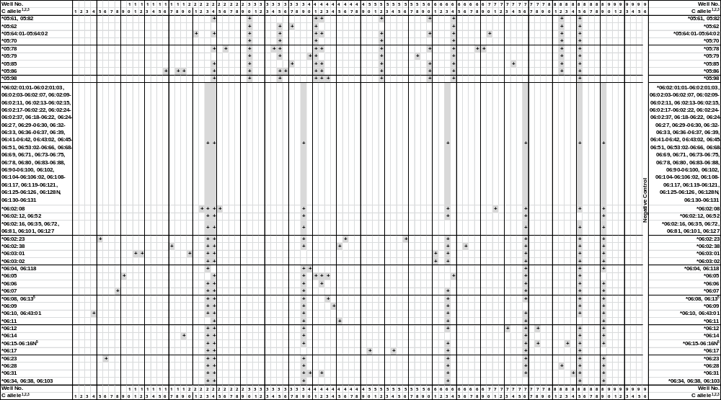
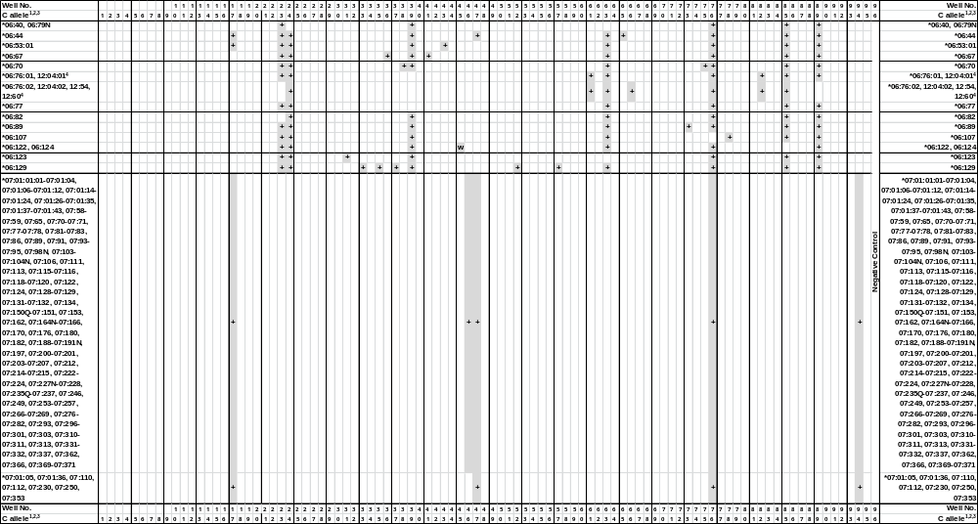
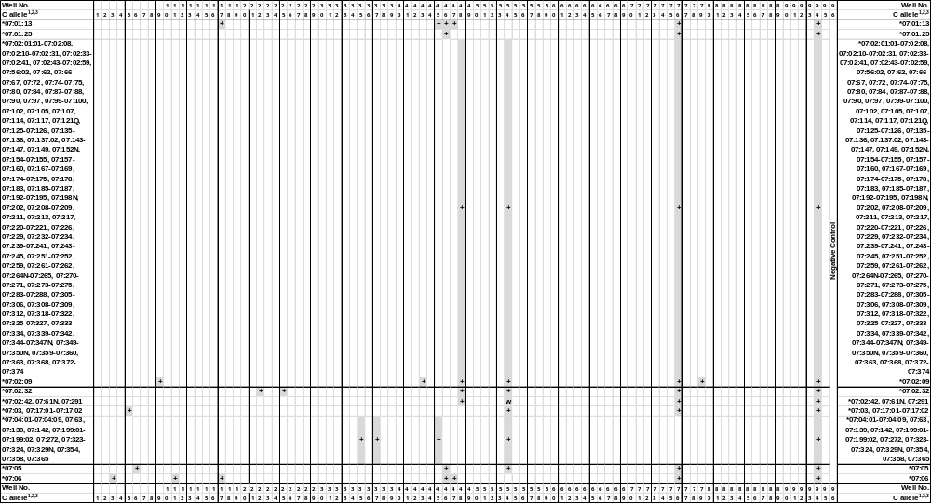
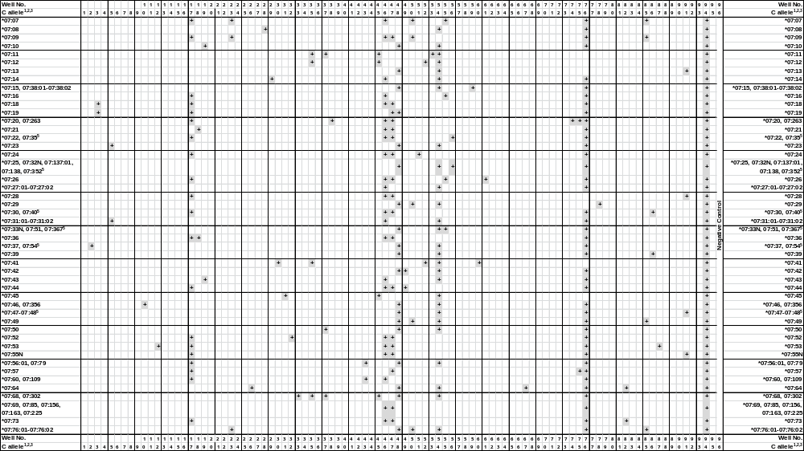
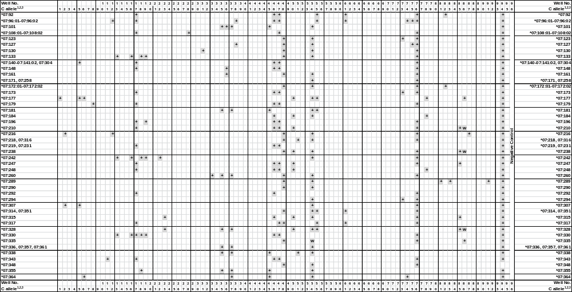
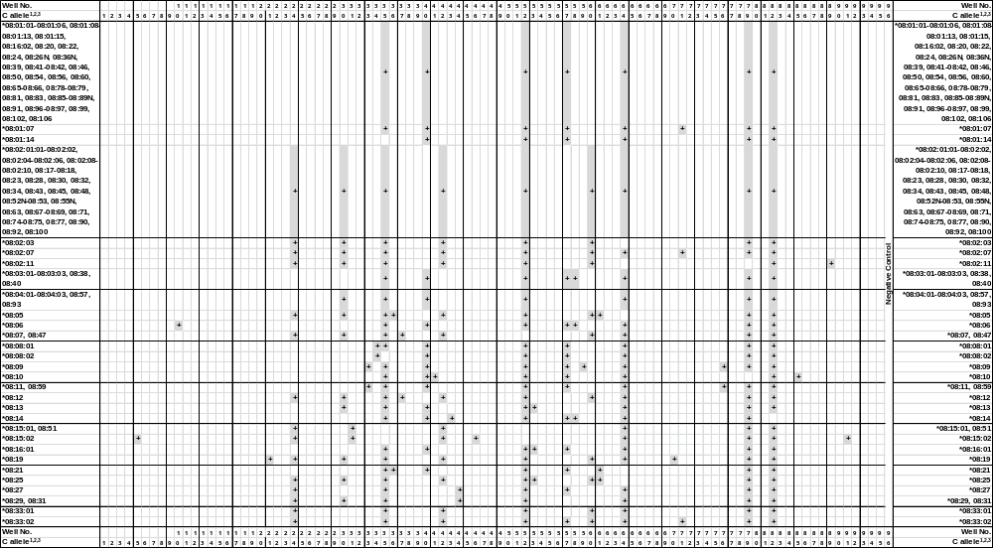
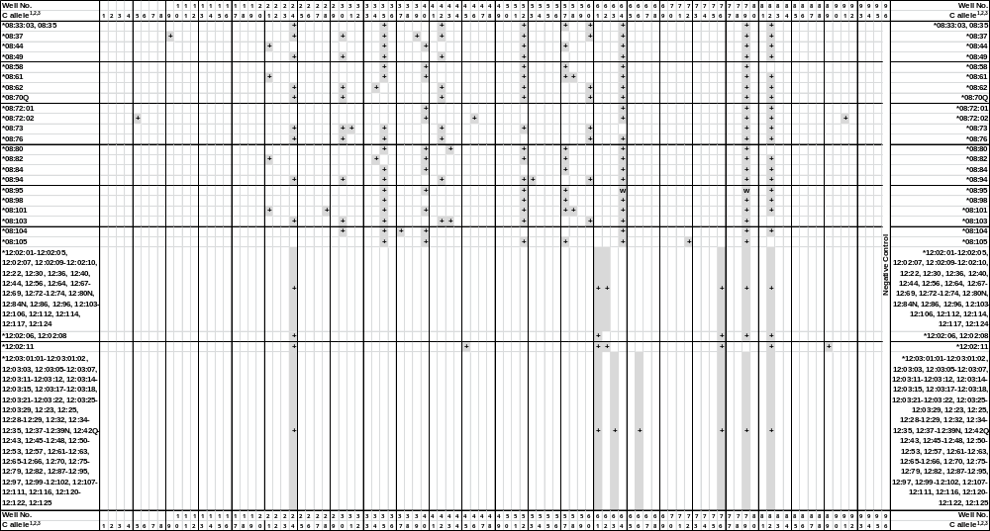
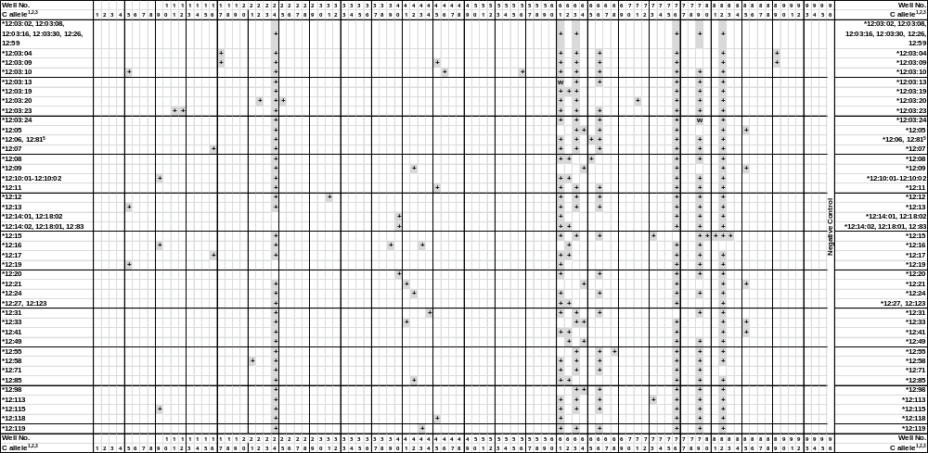
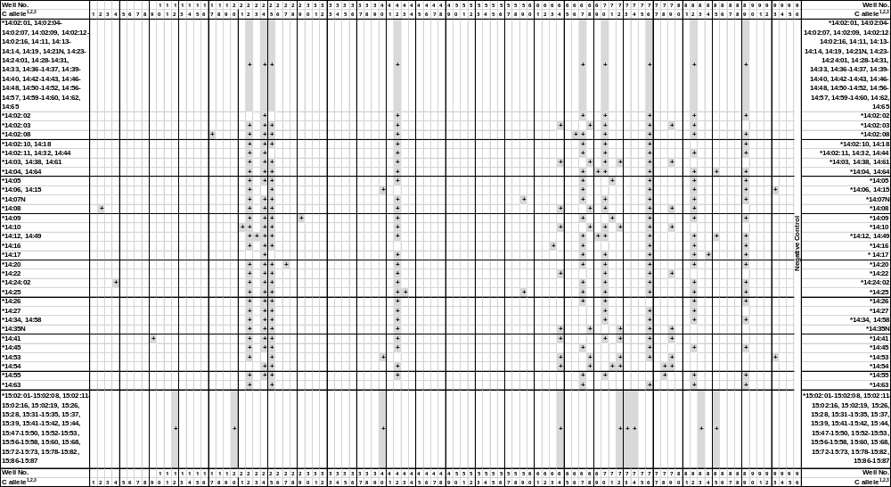
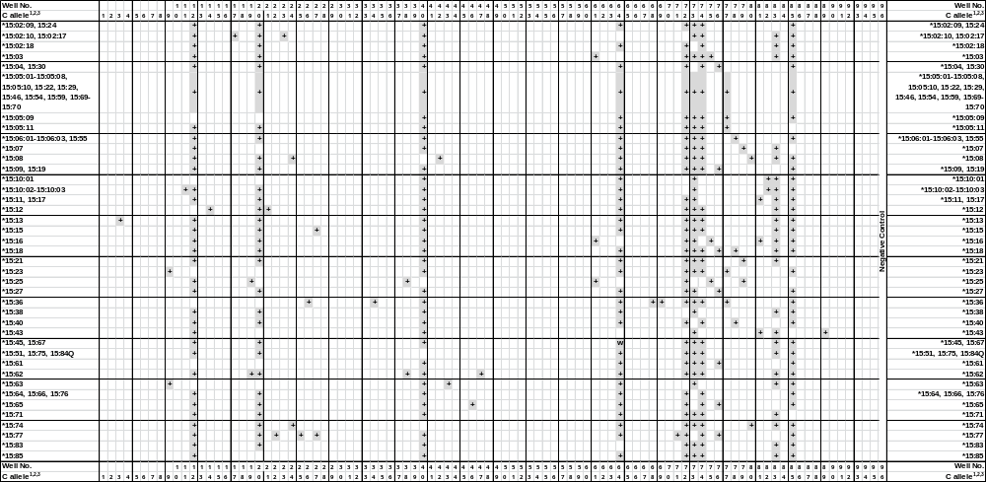
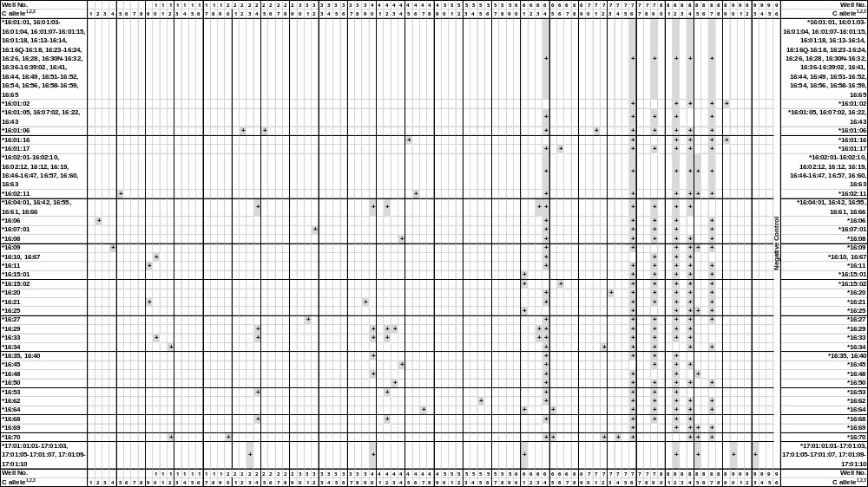
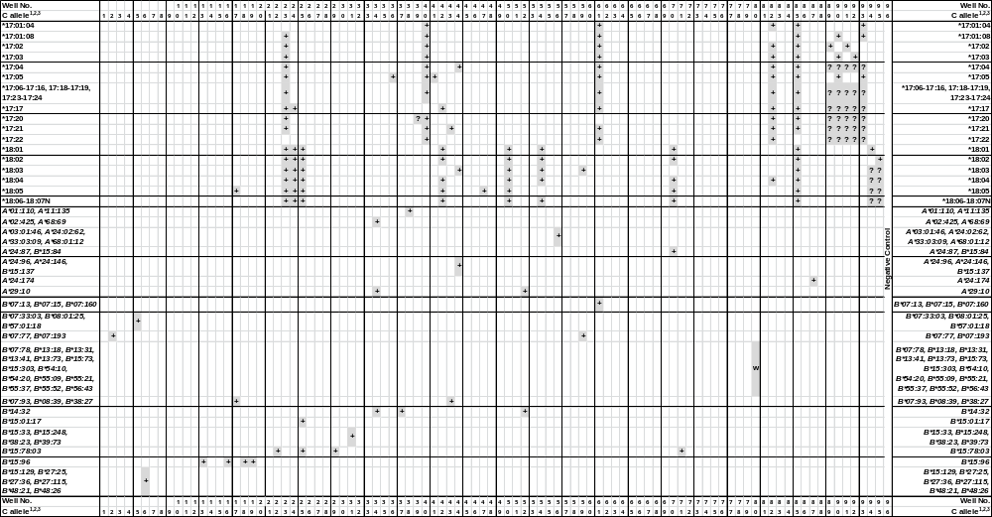
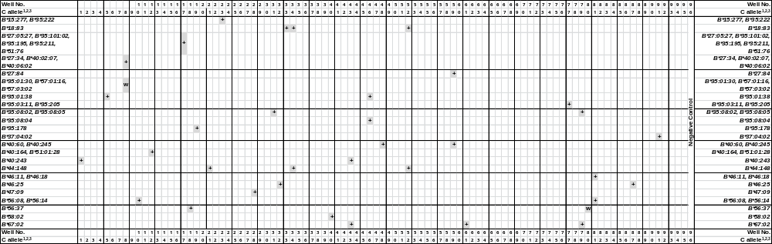

¹HLA-C alleles listed on the IMGT/HLA web page 2014-April-14, release 3.16.0, www.ebi.ac.uk/imgt/hla.
All HLA-C genotypes defined as Common in the CWD2.0.0 catalogue give rise to unique amplification patterns (S. J. Mack, P. Cano, J. A. Hollenbach et al.Common and well-documented HLA alleles: 2012 update to the CWD catalogue. Tissue Antigens, 2013, 81, 194–203).
²Alleles that have been deleted from or renamed in the official WHO HLA Nomenclature up to and including the last IMGT/HLA database release can be retrieved from web page http://hla.alleles.org/alleles/deleted.html.
³Primer mix 2: Specific PCR fragment of 95 bp in the C*04:05 and 07:54 alleles. Specific PCR fragment of 215 bp in the C*01:05, 01:77, 07:37, 07:216, 07:307, 14:08 and 16:06 and in the B*07:77 and B*07:193 alleles.
Primer mix 3: Specific PCR fragment of 200 bp in the C*01:06 alleles. Specific PCR fragment of 225 bp in the C*07:06 and 07:18-07:19 alleles. Specific PCR fragment of 290 bp in the C*01:11 allele. Specific PCR fragment of 365 bp in the C*15:13 allele.
Primer mix 4: Specific PCR fragment of 100 bp in the C*02:34 and 16:09 alleles. Specific PCR fragment of 200 bp in the C*01:07, 06:10, 06:43:01 and 14:24:02 alleles.
Primer mix 5: Specific PCR fragment of 150 bp in the C*03:04:19, 03:113, 04:01:43, 05:01:17, 05:09:02, 05:17, 07:03, 07:17:01-07:17:02, 07:23, 07:140-07:141:02, 07:304, 07:307, 08:15:02, 08:72:02, and 12:13 and in the B*07:33:03, B*08:01:25, B*35:01:38 and B*57:01:18 alleles. Specific PCR fragment of 210 bp in the C*01:08 and 12:19 alleles. Specific PCR fragment of 300 bp in the C*07:31:01-07:31:02 and 07:177 alleles. Specific PCR fragment of 150 bp and 300 bp in the C*06:02:23, 12:03:10 and 16:02:11 alleles.

Primer mix 6: Specific PCR fragment of 105 bp in the C*03:24 allele. Specific PCR fragment of 150 bp in the C*01:20 allele. Specific PCR fragment of 190 bp in the C*01:60, 07:05, 07:177 and 07:364 and in the B*27:36, B*48:21 and B*48:26 alleles. Specific PCR fragment of 210 bp in the C*01:04, 01:09 and 06:23 and in the B*15:129, B*27:25 and B*27:115 alleles. Specific PCR fragment of 260 bp in the C*01:15 and 03:33 alleles.
Primer mix 8: Specific PCR fragment of 105 bp in the C*02:03, 02:16:02, 02:18, 03:03:22, 03:04:34, and 06:07 and in the B*27:34, B*35:01:30^{w}, B*40:02:07, 40:06:02, B*57:01:16^{w} and 57:03:02^{w} alleles. Specific PCR fragment of 135 bp in the C*02:20 alleles. Specific PCR fragment of 595 bp in the C*07:179 alleles.
Primer mix 10: Specific PCR fragment of 105 bp in the C*07:46 and 07:356 and in the B*56:08 and 56:14 alleles. Specific PCR fragment of 130 bp in the C*02:07, 16:10 and 16:67 alleles. Specific PCR fragment of 270 bp in the C*08:06 and 16:33 alleles.
Primer mix 11: Specific PCR fragment of 75 bp in the C*02:08, 02:42, 03:11:01-03:11:02, 03:18:02, 03:37:01-03:37:02, 03:64:01, 06:03:01, 12:03:23 and 15:10:02-15:10:03 alleles. Specific PCR fragment of 160 bp in the C*03:46 and 04:16 alleles. Specific PCR fragment of 505 bp in the C*07:06 and 07:343 alleles.
Primer mix 12: Specific PCR fragment of 70 bp in the C*07:53 and 07:216 alleles. Specific PCR fragment of 280 bp in the C*02:02:01-02:02:03, 02:02:05-02:03, 02:04^{w}, 02:05:01-02:13, 02:14^{w}, 02:15-02:25Q, 02:26:02-02:32, 02:34-02:40, 02:42-02:81, 03:02:01-03:02:09, 03:02:11-03:02:12, 03:04:01:01-03:04:25, 03:04:27-03:10, 03:14-03:17, 03:19, 03:23-03:29, 03:32-03:38:02, 03:40:01-03:42, 03:44-03:48, 03:51, 03:54, 03:57, 03:60, 03:63-03:64:01, 03:65, 03:70-03:74, 03:77-03:78, 03:80, 03:82, 03:84, 03:87, 03:89-03:95, 03:98, 03:100-03:101, 03:104-03:111, 03:113-03:115, 03:117-03:118, 03:121N, 03:123, 03:125, 03:128-03:131, 03:134-03:136, 03:138-03:140, 03:143, 03:145-03:149, 03:153-03:155, 03:157, 03:159, 03:162-03:164, 03:169Q, 03:172-03:174, 03:178-03:181, 03:183-03:184, 03:186:01-03:186:02, 03:190-03:191, 03:193-03:194, 03:197-03:201N, 03:208N-03:213, 03:215-03:216, 03:218-03:219, 03:221-03:222, 03:224N-03:226, 03:232-03:236, 03:238-03:240, 03:244Q-03:246, 04:03:01-04:03:02, 04:06, 04:16, 04:80, 04:107, 04:147, 04:160, 05:58:01, 06:03:01, 07:96:01-07:96:02, 12:03:23, 15:02:01-15:05:08, 15:05:10-15:09, 15:10:02-15:11, 15:13, 15:15-15:19, 15:21-15:22, 15:24-15:35, 15:37-15:60, 15:62, 15:64-15:87, 16:34 and 16:70 and in the B*40:164, B*51:01:28 alleles.
Primer mix 16: Specific PCR fragment of 245 bp in the C*03:53, 12:07 and 12:17 alleles. Specific PCR fragment of 275 bp in the C*01:65, 03:05, 03:13:01-03:13:02, 03:17, 03:25, 03:27, 03:35, 03:71, 03:167, 03:178, 03:198, 05:86, 07:133, 07:242 and 07:330 and in the B*15:96 alleles.
Primer mix 17: Specific PCR fragment of 110 bp in the C*03:08, 03:29, 03:246, 06:44, 07:01:01:01-07:01:24, 07:01:26-07:01:43, 07:06-07:07, 07:09, 07:16, 07:18-07:20, 07:22, 07:24, 07:26, 07:28, 07:30, 07:35-07:36, 07:40, 07:44, 07:52-07:53, 07:55N, 07:57-07:59, 07:65, 07:70-07:71, 07:73, 07:77-07:78, 07:81-07:83, 07:86, 07:89, 07:91-07:96:02, 07:98N, 07:103-07:104N, 07:106, 07:108:01-07:108:02, 07:110-07:113, 07:115-07:116, 07:118-07:120, 07:122, 07:124, 07:128-07:129, 07:131-07:132, 07:134, 07:140-07:141:02, 07:148, 07:150Q-07:151, 07:153, 07:162, 07:164N-07:166, 07:170, 07:173, 07:176, 07:179-07:180, 07:182, 07:188-07:191N, 07:196-07:197, 07:200-07:201, 07:203-07:207, 07:210, 07:212, 07:214-07:215, 07:219, 07:222-07:224, 07:227N-07:228, 07:230-07:231, 07:235Q-07:237, 07:246-07:250, 07:253-07:257, 07:263, 07:266-07:269, 07:276-07:282, 07:292-07:293, 07:296-07:301, 07:303-07:304, 07:310-07:311, 07:313, 07:317, 07:330-07:332, 07:337, 07:343, 07:353, 07:362, 07:366, 07:369-07:371, 15:02:10, 15:02:17 and 18:05 alleles.
Specific PCR fragment of 185 bp in the C*01:51, 03:03:01-03:03:25, 03:11:01-03:11:02, 03:13:01-03:13:02, 03:18:01-03:18:02, 03:20N-03:22Q, 03:30, 03:39, 03:43:01-03:43:02, 03:49-03:50, 03:52-03:53, 03:55-03:56, 03:58-03:59, 03:61-03:62, 03:66-03:69, 03:75-03:76, 03:79, 03:81, 03:83, 03:85-03:86, 03:88, 03:96-03:97, 03:102-03:103, 03:112, 03:116:01-03:116:02, 03:119-03:120, 03:122, 03:124, 03:126-03:127, 03:132-03:133, 03:141-03:142, 03:144, 03:150-03:152, 03:158, 03:160-03:161, 03:165, 03:167-03:168, 03:171, 03:175-03:177, 03:182, 03:185, 03:187-03:189N, 03:192, 03:195-03:196, 03:202-03:207, 03:214, 03:217, 03:220, 03:223, 03:227-03:231, 03:237, 03:241-03:243, 06:53:01, 07:56:01 and 07:79 and in the B*07:93, B*08:39, B*35:101:02, 35:195, 35:211, B*38:27 and B*51:76 alleles.
Specific PCR fragment of 565 bp in the C*01:02:18, 06:02:38, 12:03:04, 12:03:09 and 14:02:08 and in the B*27:05:27 alleles. Specific PCR fragment of 110 bp and 185 bp in the C*03:31, 07:60 and 07:109 alleles.
Primer mix 18: Specific PCR fragment of 90 bp in the C*03:21 and 03:142 and in the B*15:96 alleles. Specific PCR fragment of 185 bp in the C*07:21 allele. Specific PCR fragment of 225 bp in the C*03:23, 03:28 and 03:49 alleles. Specific PCR fragment of 255 bp in the C*03:09, 03:22Q, 03:42, 03:71, 03:89, 03:116:01, 03:119, 03:139, 03:169Q, 03:199, 03:240, 05:86, 07:36, 07:133, 07:242, 07:330 and 07:355 and in the B*56:37 alleles.
Primer mix 19: Specific PCR fragment of 105 bp in the C*03:36, 03:77 and 03:187 alleles. Specific PCR fragment of 265 bp in the C*03:13:01-03:13:02, 03:35, 03:178, 03:198, 05:86, 07:133, 07:242 and 07:330 and in the B*15:96 alleles. Specific PCR fragment of 305 bp in the C*03:32, 03:45, 03:136, 04:80, 04:100, 06:14, 07:10, 07:43, 07:196, 15:25 and 15:62 and in the B*35:178 alleles. Specific PCR fragment of 540 bp in the C*03:15, 03:32, 03:45, 03:60, 03:136, 07:133, 07:242 and 07:330 alleles.
Primer mix 21: Specific PCR fragment of 190 bp in the C*03:30, 03:65, 04:18, 04:52, 04:55, 05:55, 12:58, 14:10 and 15:12 alleles. Specific PCR fragment of 220 bp in the C*04:19 alleles. Specific PCR fragment of 250 bp in the C*03:50 alleles. Specific PCR fragment of 280 bp in the C *04:120, 05:10, 05:64:01-05:64:02, 08:19, 08:44, 08:61, 08:82, 08:101 and in the B*44:148 alleles.
Primer mix 22: Specific PCR fragment of 80 bp in the C*03:02:01-03:02:12, 03:15-03:16, 03:33, 03:36, 03:40:01, 03:40:03, 03:42-03:43:01, 03:60, 03:84, 03:89, 03:95, 03:108, 03:110, 03:121N, 03:132, 03:139, 03:146, 03:169Q, 03:175, 03:194, 03:197-03:201N, 03:216, 03:221-03:222, 03:224N-03:226, 03:238, 03:240, 03:245, 04:54, 07:02:32, 07:242, 14:08-14:09, 14:28 and 15:77 and in the B*15:78:03 alleles. Specific PCR fragment of 140 bp in the C*03:17, 04:37, 14:24:02 and 14:26 alleles. Specific PCR fragment of 80 bp and 140 bp in the C*03:71, 06:02:08, 12:03:20, 14:02:01, 14:02:03-14:07N, 14:10-14:16, 14:18-14:24:01, 14:27, 14:29-14:53, 14:56-14:65 and 16:01:06 alleles.
Primer mix 23: Specific PCR fragment of 150 bp in the C*01:14, 02:02:13, 03:07, 03:10, 03:15, 03:29, 03:45, 03:163, 04:01:23, 05:01:12, 05:29:02, 06:02:01:01-06:02:01:03, 06:02:03-06:04, 06:06-06:10, 06:12-06:76:01, 06:77-06:81, 06:83-06:131, 07:07, 07:09, 07:76:01-07:76:02, 07:315, 07:328, 12:04:01, 14:12, 14:49, 15:02:10, 15:02:17, 17:01:01:01-17:01:03, 17:01:05-17:21, 17:23-17:24 and 18:01-18:07N and in the B*15:277 and B*35:222 alleles. Specific PCR fragment of 240 bp in the C*05:13 allele.
Primer mix 26: Specific PCR fragment of 145 bp in the C*04:07, 04:27, 04:89, 04:153, 05:78, 07:64 and 15:36 alleles. Specific PCR fragment of 170 bp in the C*02:09 alleles.
Primer mix 27: Specific PCR fragment of 135 bp in the C*01:35, 04:08, 04:34, 04:147 and 14:20 alleles. Specific PCR fragment of 170 bp in the C*04:30, 15:15 and 15:77 alleles. Specific PCR fragment of 220 bp in the C*04:09N allele.
Primer mix 29: Specific PCR fragment of 130 bp in the C*03:05, 03:13:02, 03:25, 03:27, 03:135, 03:167, 04:15:01, 04:15:03 and 14:09 and in the B*15:78:03 alleles. Specific PCR fragment of 190 bp in the C*02:15 allele. Specific PCR fragment of 290 bp in the C*07:14 allele.
Primer mix 31: Specific PCR fragment of 150 bp in the C*01:13, 02:51, 03:87, 05:09:01-05:09:02, 05:17, 05:52, 07:130, 08:15:01-08:15:02, 08:51, 08:73, 12:12 and 16:27 and in the B*15:33, B*15:248, B*35:08:02, B*35:08:05, B*38:23 and B*39:73 alleles. Specific PCR fragment of 285 bp in the C*02:57, 04:40, 06:123 and 07:45 and in the B*38:23 and B*39:73 alleles.
Primer mix 32: Specific PCR fragment of 120 bp in the C*05:03 and 07:52 alleles. Specific PCR fragment of 180 bp in the C*03:48 allele. Specific PCR fragment of 210 bp in the C*16:07:01 and in the B*46:25 allele.
Primer mix 33: Specific PCR fragment of 190 bp in the C*04:28 allele. Specific PCR fragment of 225 bp in the C*05:04:01-05:04:02, 06:129, 07:68, 07:260, 07:302, 08:09, 08:11 and 08:59 and in the B*18:83 alleles.
Primer mix 34: Specific PCR fragment of 220 bp in the C*03:231^{w}, 04:10, 04:11^{w}, 04:36^{w}, 04:55^{w}, 04:153, 04:169, 05:78 and 15:36 alleles. Specific PCR fragment of 275 bp in the C*05:05, 05:07N, 08:08:01-08:08:02, 08:62, 08:82 and in the A*02:425, A*29:10, A*68:69, B*14:32, B*18:83 and B*44:148 alleles.
Primer mix 36: Specific PCR fragment of 90 bp in the C*01:65, 03:28, 03:49, 03:117, 05:06 and 05:86 alleles. Specific PCR fragment of 120 bp in the C*05:15 allele. Specific PCR fragment of 160 bp in the C*03:25, 04:129, 05:42, 05:46, 06:67, 07:101, 07:148, 07:161, 08:05, 08:21 and 17:05 alleles. Specific PCR fragment of 210 bp in the C*03:06 and C*03:26 allele.
Primer mix 37: Specific PCR fragment of 80 bp in the C*07:50 allele. Specific PCR fragment of 130 bp in the C*05:23, 05:62, 07:04:01-07:04:09, 07:11, 07:63, 07:68, 07:101, 07:139, 07:142, 07:181, 07:199:01-07:199:02, 07:260, 07:272, 07:302, 07:323-07:324, 07:328-07:329N, 07:336, 07:338, 07:354-07:355, 07:357-07:358, 07:361, 07:364-07:365, 08:07, 08:47 and 08:104 allele. Specific PCR fragment of 195 bp in the C*05:14 allele. Specific PCR fragment of 235 bp in the C*05:19 allele. Specific PCR fragment of 280 bp in the C*05:16, 05:85, 06:129, 07:364 and 08:12 and in the B*14:32 allele.
Primer mix 43: Specific PCR fragment of 100 bp in the C*01:21, 02:42, 04:140, 04:166, 05:98, 06:05, 07:02:09, 08:14, 08:80, 08:103, 12:16 and 15:63 and in the B*67:02 alleles.
Specific PCR fragment of 155 bp in the C*06:13 allele. Specific PCR fragment of 240 bp in the C*01:10, 01:51, 02:05:01-02:05:03, 02:17, 03:11:01-03:11:02, 03:39, 06:08, 06:53:01, 07:56:01, 07:60, 07:79, 07:109, 12:119, 14:25, 16:29, 16:50 and 17:21 and in the B*07:93, B*08:39, B*38:27 and B*40:243 alleles.
Primer mix 44: Specific PCR fragment of 90 bp in the C*03:20N allele. Specific PCR fragment of 135 bp in the C*16:08 allele. Specific PCR fragment of 160 bp in the C*02:22, 04:14, 04:68, 04:94:01-04:94:02, 05:08, 05:52, 05:89, 06:09, 08:27, 08:29, 08:31, 12:31, 16:45, 17:04 and 18:03 and in the A*24:96, A*24:146 and B*15:137 alleles.
Primer mix 45: Specific PCR fragment of 140 bp in the C*06:11, 06:122^{w}, 06:124^{w}, 07:01:13, 07:04:01-07:04:09, 07:11-07:12, 07:45, 07:63, 07:68, 07:101, 07:139, 07:142, 07:181, 07:199:01-07:199:02, 07:272, 07:302, 07:323-07:324, 07:329N, 07:338, 07:354-07:355, 07:358, 07:364-07:365, 12:02:11, 12:11, 12:118 and 16:01:16 alleles. Specific PCR fragment of 255 bp in the C*03:47 allele. Specific PCR fragment of 550 bp in the C*06:02:38 allele. Specific PCR fragment of 140 bp and 550 in the C12:03:09 allele.
Primer mix 49: Specific PCR fragment of 85 bp in the C*04:25 allele. Specific PCR fragment of 130 bp in the C*04:24 allele. Specific PCR fragment of 170 bp in the C*04:26 and 07:44 allele. Specific PCR fragment of 250 bp in the C*07:42 allele.
Primer mix 50: Specific PCR fragment of 240 bp in the C*03:04:19, 03:113, 07:29, 07:177, 07:184 and 07:248 allele. Specific PCR fragment of 425 bp in the C*06:17, 07:07, 07:09, 07:49, 07:76:01-07:76:02, 07:210, 07:238, 07:247, 07:315, 07:328 and 18:01-18:07N alleles.
Primer mix 51: Specific PCR fragment of 240 bp in the C*01:16-01:19, 01:21, 01:23, 07:316 and 07:338 alleles. Specific PCR fragment of 275 bp in the C*07:24 and 07:218 alleles.
Primer mix 53: Specific PCR fragment of 80 bp in the C*07:11 allele. Specific PCR fragment of 115 bp in the C*05:12 allele. Specific PCR fragment of 265 bp in the C*05:29:01-05:29:02, 08:13, 08:16:01, 08:25 and 08:94 allele.
Primer mix 55: Specific PCR fragment of 165 bp in the C*04:11, 04:33, 04:169 and 16:62 allele. Specific PCR fragment of 220 bp in the C*07:26, 07:33N, 07:92, 07:96:01-07:96:02, 07:314, 07:317 and 07:351 alleles. Specific PCR fragment of 340 bp in the C*01:12:01-01:12:02, 01:34, 01:49-01:50 and 01:79:01-01:79:02 alleles. Specific PCR fragment of 465 bp in the C*07:07, 07:16, 07:51, 07:177, 07:181, 07:328 and 07:367 alleles. Specific PCR fragment of 340 bp and 465 bp in the C*01:21 allele.
Primer mix 56: Specific PCR fragment of 100 bp in the C*07:32N allele. Specific PCR fragment of 125 bp in the C*06:02:23, 07:22, 07:25, 07:137:01, 07:138, 12:03:10 and in the A*03:01:46, A*24:02:62, A*33:03:09 and A*68:01:12 alleles. Specific PCR fragment of 250 bp in the C*07:35 and 07:352 alleles.
Primer mix 59: Specific PCR fragment of 110 bp in the C*08:09 allele. Specific PCR fragment of 150 bp in the C*02:11, 03:34, 03:142, 04:32, 04:77, 14:07N, 14:25 and 18:03 and in the B*27:84 allele. Specific PCR fragment of 185 bp in the C*04:77 allele. Specific PCR fragment of 230 bp in the C*02:77 and 07:15 and in the B*07:77, 07:193, B*40:60 and 40:245 allele. Specific PCR fragment of 275 bp in the C*07:38:01-07:38:02 and in the B*07:77, 07:193, B*40:60 and B*40:245 alleles.
Primer mix 65: Specific PCR fragment of 150 bp in the C*12:06 allele. Specific PCR fragment of 415 bp in the C*03:08, 03:29, 03:31, 03:246, 04:112, 04:169, 05:36, 06:44, 12:08, 12:81, 16:64 and 16:70 allele.
Primer mix 73: Specific PCR fragment of 210 bp in the C*06:12 allele. Specific PCR fragment of 330 bp in the C*01:90, 02:06, 02:23, 02:36, 02:68, 03:81, 03:175, 03:199, 03:245, 04:108, 06:89, 07:123, 07:173, 07:294, 12:15, 12:113, 15:02:01-15:02:17, 15:02:19-15:03, 15:05:01-15:13, 15:15-15:19, 15:21-15:24, 15:26-15:29, 15:31-15:39, 15:41-15:63, 15:67-15:75, 15:78-15:87 and 16:20 allele.
Primer mix 74: Specific PCR fragment of 90 bp in the C*01:03, 01:24, 01:78, 03:58, 04:37, 05:85 and 07:364 allele. Specific PCR fragment of 175 bp in the C*03:08, 03:29, 03:31, 03:246, 07:20, 07:96:01-07:96:02, 07:263, 15:02:01-15:09, 15:12-15:13, 15:15, 15:18-15:19, 15:21-15:24, 15:26, 15:28-15:37, 15:39-15:42, 15:44-15:62, 15:64-15:87 and 16:70 allele.
Primer mix 75: Specific PCR fragment of 145 bp in the C*07:57 allele. Specific PCR fragment of 195 bp in the C*02:12, 02:49, 02:55, 03:15, 03:27, 03:38:01-03:38:02, 03:69, 03:130, 03:136, 03:163, 03:246w, 04:03:01, 04:06, 04:16, 04:80, 04:107, 04:147, 04:160, 06:70, 07:20, 07:96:01-07:96:02, 07:127, 07:263, 15:03, 15:16 and 15:25 alleles.
Primer mix 78: Specific PCR fragment of 205 bp in the C*06:12 allele. Specific PCR fragment of 235 bp in the C*06:16N allele. Specific PCR fragment of 310 bp in the C *01:02:01-01:02:24, 01:02:26, 01:05-01:20, 01:22-01:23, 01:25-01:33, 01:35-01:53, 01:56N-01:77, 01:79:01-01:89N, 01:92-01:93, 02:19, 02:23, 03:03:01-03:11:02, 03:13:01-03:13:02, 03:17-03:18:02, 03:20N-03:25, 03:27-03:32, 03:34-03:35, 03:37:01-03:39, 03:41, 03:44-03:57, 03:59, 03:61-03:70, 03:72-03:83, 03:85-03:88, 03:90-03:94, 03:96-03:101, 03:103-03:107, 03:109, 03:111-03:118, 03:120, 03:122-03:131, 03:133-03:138, 03:140-03:145, 03:147-03:168, 03:170-03:174, 03:176-03:189N, 03:191-03:193, 03:195-03:196, 03:202-03:215, 03:217-03:220, 03:223, 03:227-03:237, 03:239, 03:241-03:244Q, 03:246, 04:89, 04:135, 05:47, 06:107, 07:29, 07:177, 07:184, 07:248, 14:54-14:55, 15:06:01-15:06:03, 15:18, 15:40, 15:55 allele. Specific PCR fragment of 260 bp in the C*06:15 allele.
Primer mix 80: Specific PCR fragment of 70 bp in the C*03:34 and 03:142 alleles. Specific PCR fragment of 160 bp in the C*01:90^{w}, 02:06, 02:47, 12:15, 15:08, 15:74, B*07:78^{w}, B*13:18^{w}, 13:31^{w}, 13:41^{w} and 13:73^{w} and in the B*15:73^{w}, 15:303^{w}, B*54:10^{w}, 54:20^{w}, B*55:09^{w}, 55:21^{w}, 55:37^{w}, 55:52^{w} and B*56:43^{w} alleles. Specific PCR fragment of 210 bp in the C*03:19, 03:44 and 03:102 and in the B*56:37^{w} alleles.
Primer mix 83: Specific PCR fragment of 240 bp in the C*06:16N allele. Specific PCR fragment of 315 bp in the C*02:06, 02:47, 03:19, 03:102, 07:289, 12:15, 15:02:01-15:02:08, 15:02:10-15:03, 15:07-15:08, 15:10:01-15:13, 15:15-15:18, 15:21, 15:26, 15:28, 15:31-15:35, 15:37-15:39, 15:41-15:45, 15:47-15:53, 15:56-15:58, 15:60, 15:62-15:63, 15:67-15:68, 15:71-15:75 and 15:78-15:87 alleles. Specific PCR fragment of 360 bp in the C*06:15 allele.
Primer mix 86: Specific PCR fragment of 150 bp in the C*07:30 allele. Specific PCR fragment of 415 bp in the C*07:39-07:40, 07:177, 07:210^{w}, 07:238^{w}, 07:328^{w} and 07:335 alleles.
Primer mix 88: Specific PCR fragment of 85 bp in the C*04:23 and 04:108 alleles. Specific PCR fragment of 195 bp in the C*04:31 allele.
Primer mix 91: Specific PCR fragment of 70 bp in the C*17:02, 17:04? and 17:06?-17:24? allele. Specific PCR fragment of 170 bp in the C*07:48 allele. Specific PCR fragment of 240 bp in the C*04:01:43, 05:01:17, 05:09:02, 05:17, 07:13, 07:28, 07:55N, 07:289, 08:15:02 and 08:72:02 and in the B*37:04:02 alleles. Specific PCR fragment of 270 bp in the C*07:47 allele.
Primer mix 92: Specific PCR fragment of 155 bp in the C*03:135 and 04:20 allele. Specific PCR fragment of 300 bp in the C*17:03, 17:04? and 17:06?-17:24? alleles.
Primer mix 93: Specific PCR fragment of 90 bp in the C*17:01:01:01-17:01:10, 17:04?, 17:05, 17:06?-17:24? alleles. Specific PCR fragment of 210 bp in the C*14:06, 14:15 and 14:53 alleles.
⁴The C*06:76:01 and C*12:04:01 alleles will give rise to identical amplification patterns. These alleles can e.g. be distinguished by the HLA-C low resolution kit, the HLA-C*06 high resolution kit and/or HLA-C*12 high resolution kit.
The C*06:76:02 and the C*12:04:02, 12:54 and 12:60 alleles will give rise to identical amplification patterns. These alleles can e.g. be distinguished by the HLA-C low resolution kit and/or HLA-C*12 high resolution kit.

⁵The following HLA-C alleles can be distinguished by the different sizes of the specific PCR product:

Alleles | Primer mix | Alleles | Primer mix
C*01:06, 01:11 | 3 | C*05:10, 05:55 | 21
C*01:15, 01:20, 01:60 | 6 | C*06:08, 06:13 | 43
C*02:11, 02:77 | 59 | C*06:15-06:16N | 78, 83
C*02:51, 02:57 | 31 | C*07:22, 07:35 | 56
C*03:06, 03:117 | 36 | C*07:25, 07:32N, 07:137:01, 07:138, 07:352 | 56
C*03:21-03:22Q, 03:116:01 | 18 | C*07:30, 07:40 | 86
C*03:30, 03:50 | 21 | C*07:33N, 07:51, 07:367 | 55
C*03:37:01-03:37:02, 03:46 | 11 | C*07:37, 07:54 | 2
C*04:08-04:09N, 04:30 | 27 | C*07:47-07:48 | 91
C*04:23, 04:31 | 88 | C*12:06, 12:81 | 65
C*04:24-04:25 | 49

The HLA-C typing kit cannot distinguish the following silent mutations: the C*01:02:01-01:02:17, 01:02:19-01:02:24 and 01:02:26 alleles, the C*01:12:01-01:12:02 alleles, the C*02:02:02:01-02:02:03, 02:02:05-02:02:07, 02:02:09-02:02:11, 02:02:14-02:02:20 and 02:02:22-02:02:26 alleles, the C*02:05:01-02:05:03 alleles, the C*02:27:01-02:27:02 alleles, the C*03:02:01-03:02:07, 03:02:09 and 03:02:11-03:02:12 alleles, the C*03:03:01-03:03:20 and 03:03:23-03:03:25 alleles, the C*03:04:01:01-03:04:14, 03:04:16-03:04:18, 03:04:20-03:04:24, 03:04:28-03:04:29, 03:04:31-03:04:33 and 03:04:35-03:04:46 alleles, the C*03:04:27 and 03:04:30 alleles, the C*03:11:01-03:11:02 alleles, the C*03:37:01-03:37:02 alleles, the C*03:38:01-03:38:02 alleles, the C*03:40:01 and 03:40:03 alleles, the C*04:01:01:01-04:01:02, 04:01:04, 04:01:06, 04:01:08, 04:01:10-04:01:17, 04:01:19-04:01:21, 04:01:24-04:01:25, 04:01:27-04:01:28, 04:01:30-04:01:33, 04:01:35-04:01:42 and 04:01:44-04:01:59 alleles, the C*04:01:05, 04:01:07, 04:01:09, 04:01:18, 04:01:22 and 04:01:26 alleles, the C*04:15:01 and 04:15:03 alleles, the C*05:01:01:01-05:01:11, 05:01:13-05:01:15, 05:01:19-05:01:21, 05:01:23 and 05:01:25-05:01:26 alleles, the C*05:01:16, 05:01:18 and 05:18:02-05:18:03 alleles, the C*05:04:01-05:04:02 alleles, the C*05:64:01-05:64:02 alleles, the C*06:02:01:01-06:02:01:03, 06:02:03-06:02:07, 06:02:09-06:02:11, 06:02:13-06:02:15, 06:02:17-06:02:22 and 06:02:24-06:02:37 alleles, the C*07:01:01:01-07:01:04, 07:01:06-07:01:12, 07:01:14-07:01:24, 07:01:26-07:01:35 and 07:01:37-07:01:43 alleles, the C*07:01:05 and 07:01:36 alleles, the C*07:02:01:01-07:02:08, 07:02:10-07:02:31, 07:02:33-07:02:41 and 07:02:43-07:02:59 alleles, the 07:17:01-07:17:02 alleles, the C*07:04:01-07:04:09 and 07:199:01-07:199:02 alleles, the C*07:27:01-07:27:02 alleles, the C*07:31:01-07:31:02 alleles, the C*07:38:01-07:38:02 alleles, the C*07:76:01-07:76:02 alleles, the C*07:96:01-07:96:02 alleles, the C*07:108:01-07:108:02 alleles, the C*07:141:01-07:141:02 alleles, the C*07:172:01-07:172:02 alleles, the C*08:01:01-08:01:06, 08:01:08-08:01:13 and 08:01:15 alleles, the C*08:02:01:01-08:02:02, 08:02:04-08:02:06 and 08:02:08-08:02:10 alleles, the C*08:03:01-08:03:03 alleles, the C*08:04:01-08:04:03 alleles, the C*12:02:01-12:02:05, 12:02:07 and 12:02:09-12:02:10 alleles, the C*12:02:06 and 12:02:08 alleles, the C*12:03:01:01-12:03:01:02, 12:03:03, 12:03:05-12:03:07, 12:03:11-12:03:12, 12:03:14-12:03:15, 12:03:17-12:03:18, 12:03:21-12:03:22 and 12:03:25-12:03:29 alleles, the C*12:03:02, 12:03:08, 12:03:16 and 12:03:30 alleles, the C*12:10:01-12:10:02 alleles, the C*14:02:01, 14:02:04-14:02:07, 14:02:09 and 14:02:12-14:02:16 alleles, the C*15:02:01-15:02:08, 15:02:11-15:02:16 and 15:02:19 alleles, the C*15:02:10 and 15:02:17 alleles, the C*15:05:01-15:05:08 and 15:05:10 alleles, the C*15:06:01-15:06:03 alleles, the C*15:10:02-15:10:03 alleles, the C*16:01:01, 16:01:03-16:01:04, 16:01:07-16:01:15 and 16:01:18 alleles, the C*16:02:01-16:02:10 and 16:02:12 alleles and the C*17:01:01:01-17:01:03, 17:01:05-17:01:07 and 17:01:09-17:01:10 alleles.

‘?’, nucleotide sequence information not available for the primer matching sequence.
‘w’, might be weakly amplified.

Changes in revision R01 compared to R00:
- The resolution capability of the kit is defined more stringently.
Changes in revision R03 compared to R02:
- The C*07:10 allele is amplified by primer mix 19. This has been corrected in the Specificity and Interpretation Tables.
Changes in revision R04 compared to R03:
- The C*14:17 and C*16:68 alleles are amplified by primer mix 84. This has been corrected in the Specificity and Interpretation Tables.

